

**School of Electrical Engineering and Computer Science**

*National University of Sciences & Technology (NUST)*

**FORMAL METHODS**

Assignment

Git link: https://github.com/bpervaiz

**Submitted by:**

Bisma Pervaiz

124642

BESE 6B

1. **Take the example of Jobshop from Uppaal demos.**
2. **Add more jobbers and accommodate the changes**

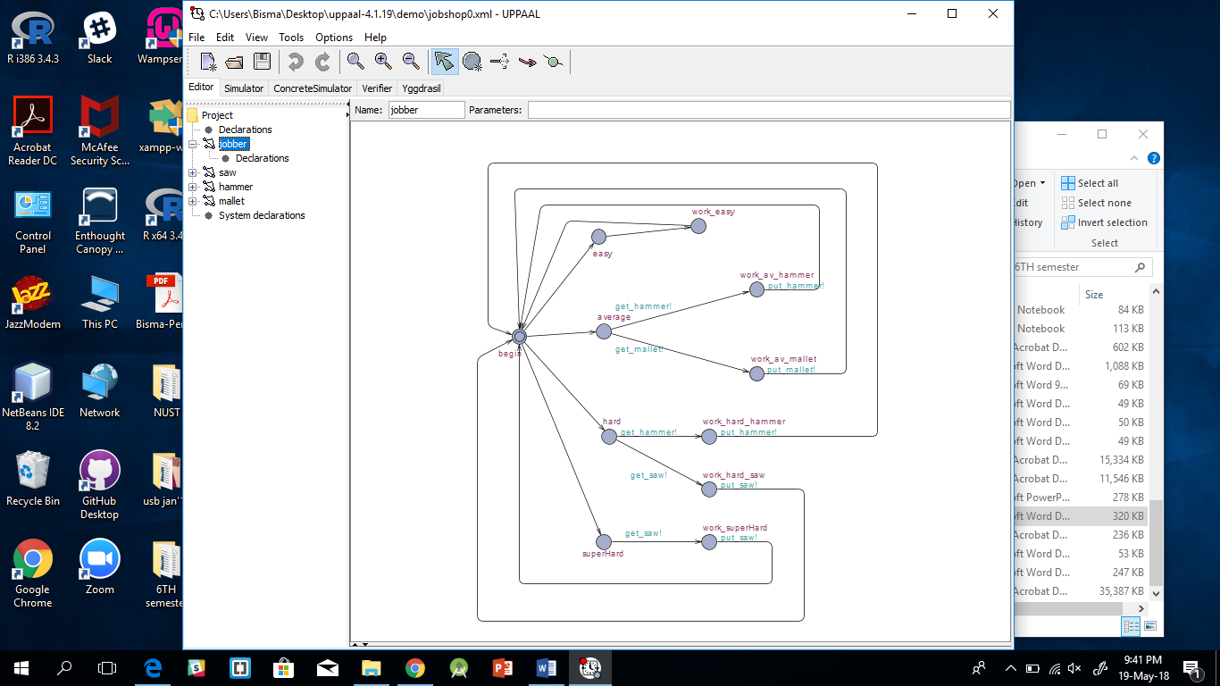

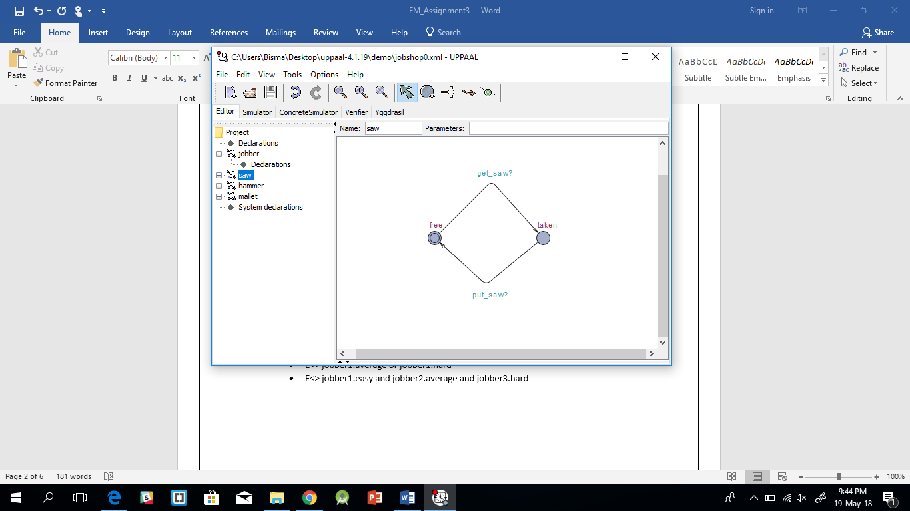

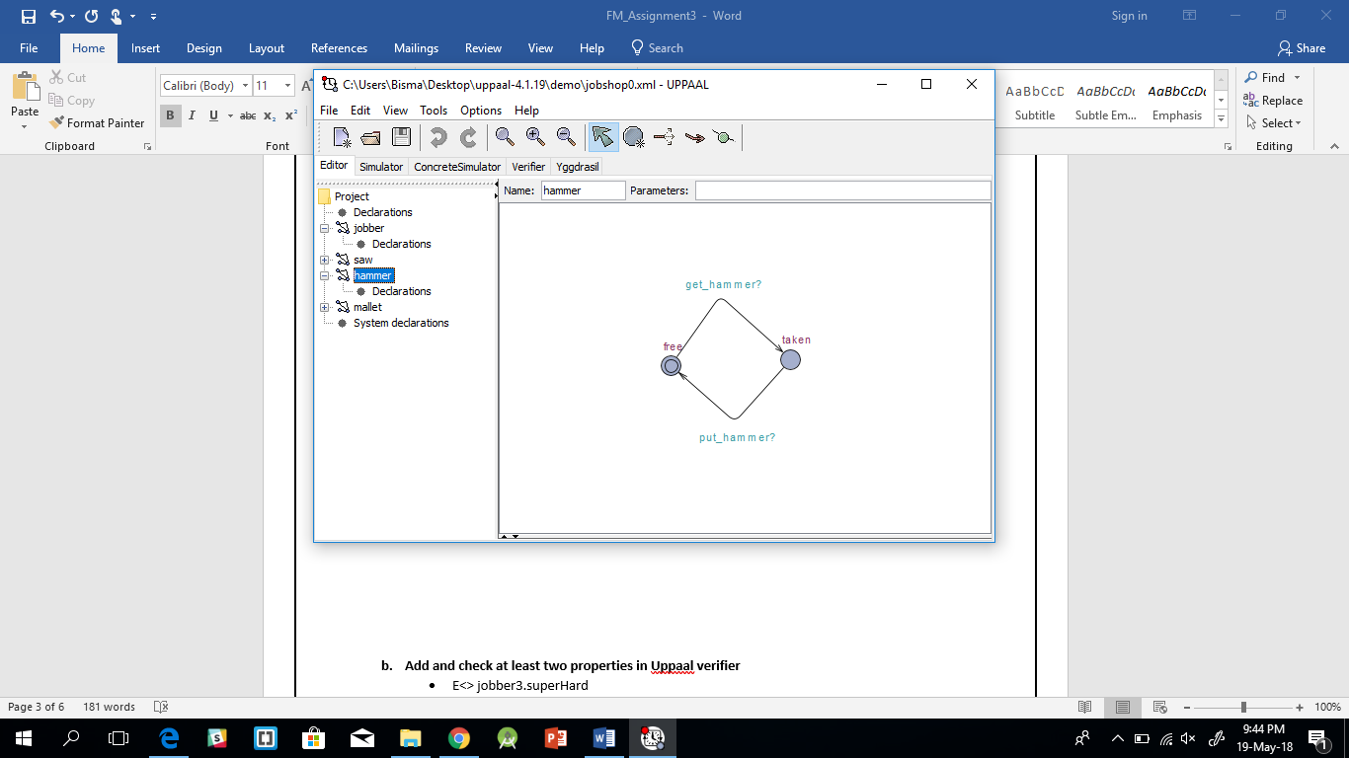

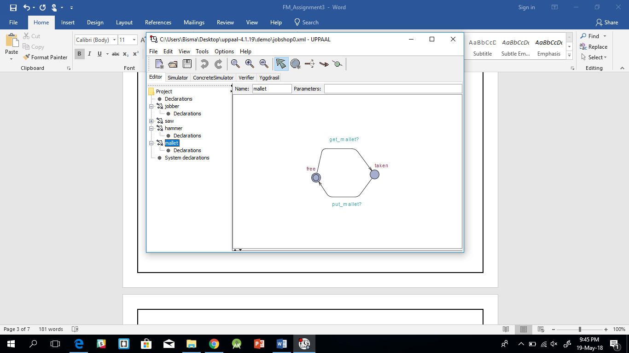

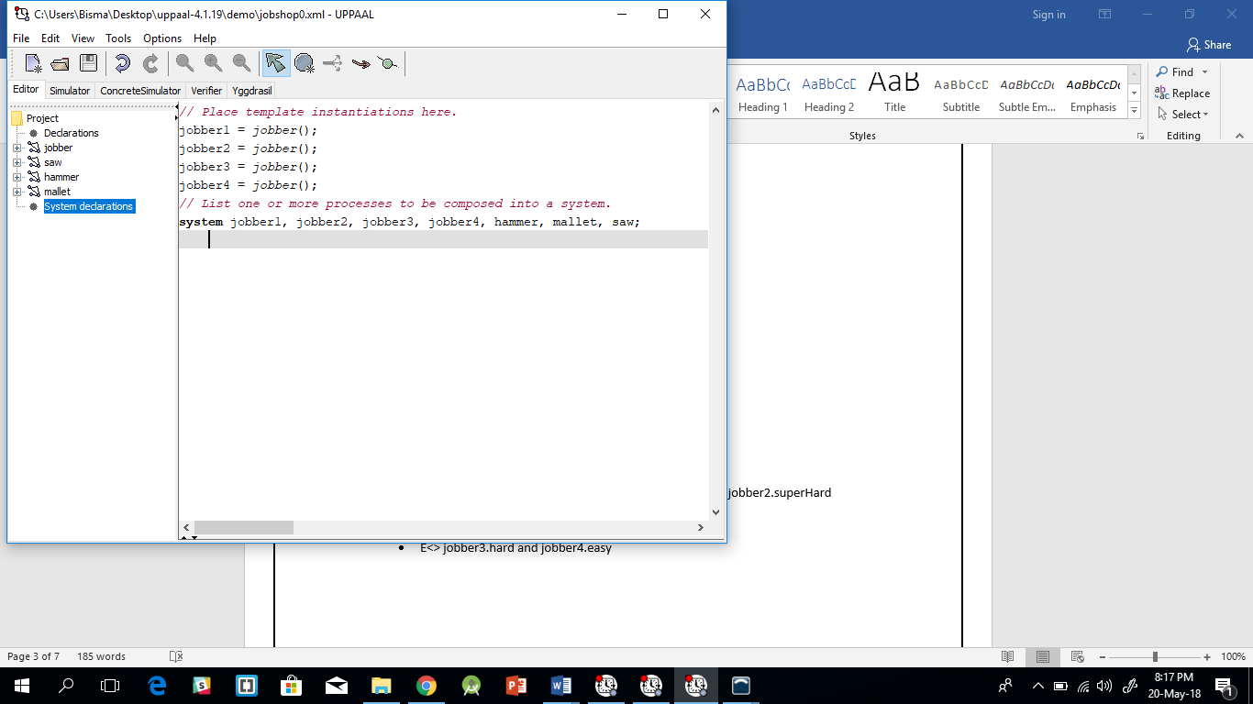

1. **Add and check at least two properties in Uppaal verifier**

* E<> jobber3.superHard
* A[ ] not(jobber1.hard and jobber1.superHard)
* A[ ] not(jobber3.average and jobber3.hard)
* E<> jobber2.easy or jobber2.average or jobber2.hard or jobber2.superHard
* E<> jobber1.average or jobber1.hard
* E<> jobber1.easy and jobber2.average and jobber3.hard
* E<> jobber3.hard and jobber4.easy

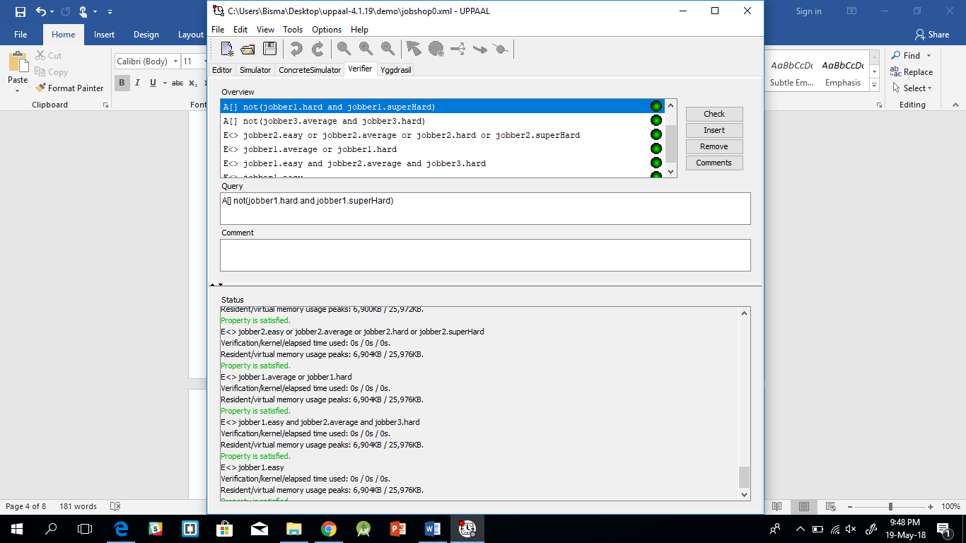

1. **The New Islamabad International Airport is operational from May 3, 2018. Traffic on Shahrah-e-Kashmir (major road) is 8 times as compared to the traffic on the minor road at the G-11 signal crossing. CDA wants NUST’s software engineers to provide a complete Uppaal diagram of traffic flow diagram with directions and proposed timings for optimal traffic flow. Diagram of all the important objects for the system is mandatory for execution in simulator. In the verifier must check the following three properties:**

**Mutex Property**

**Bounded liveness**

**Deadlock avoidance**

In my example I have r1,r2,r3,r4 where r1 is Kashmir highway, r2 is G-11 road, r3 is Zero point road and r4 is NUST road. I have give the green signal of Kashmir highway and zero-point timer of 90 sec because the traffic flow on it is 8 times heavier than G-11 and NUST intersection.

I introduced functions in UPPAAL to cater the timer; for example on r1 the guard of a variable d==1 is checked which will be set in a function called when the signal before it is operated, this ensure that the sequence remains r1,r2,r3,r4.

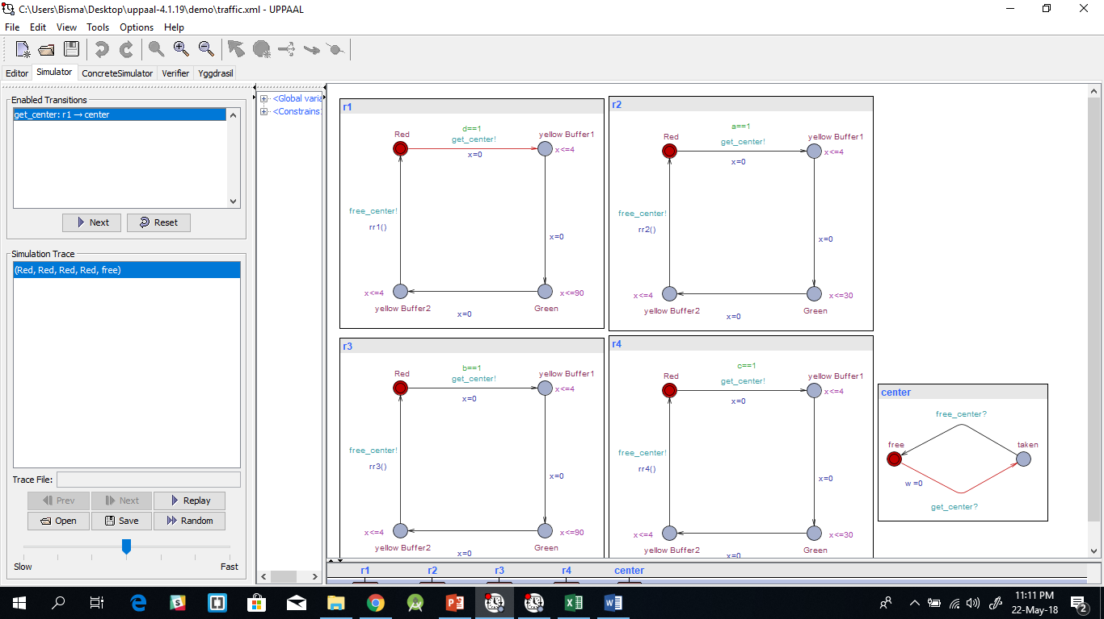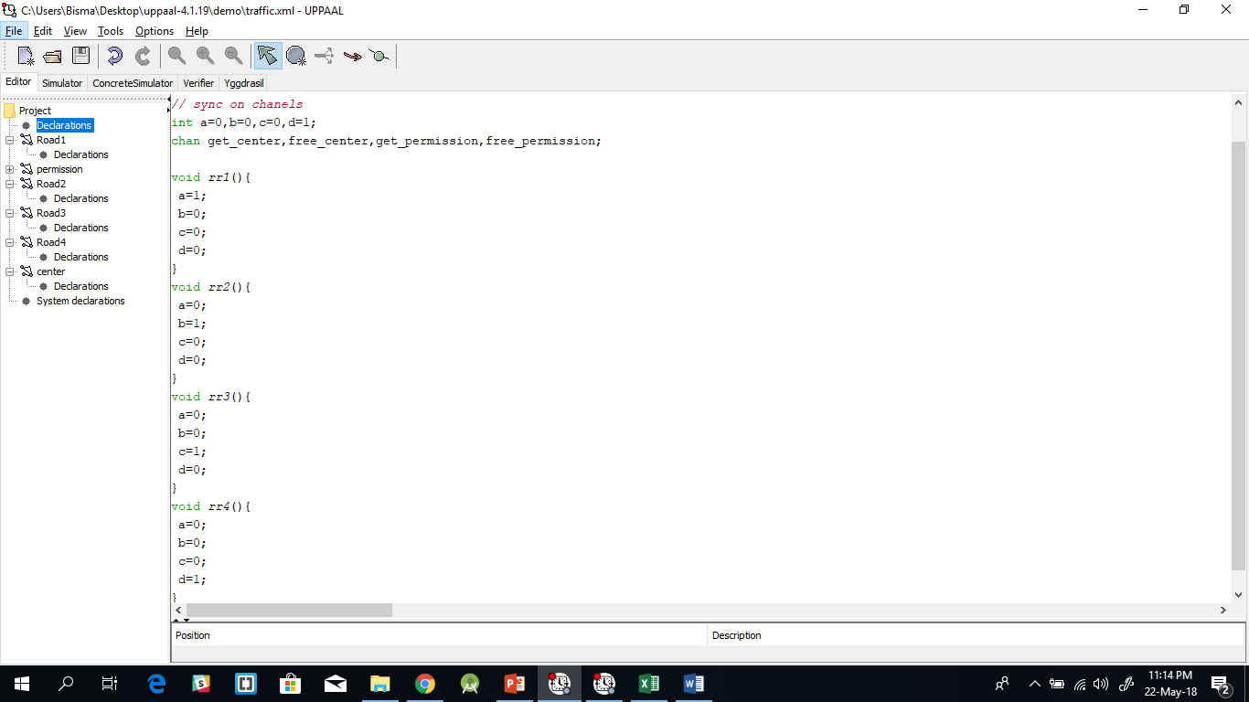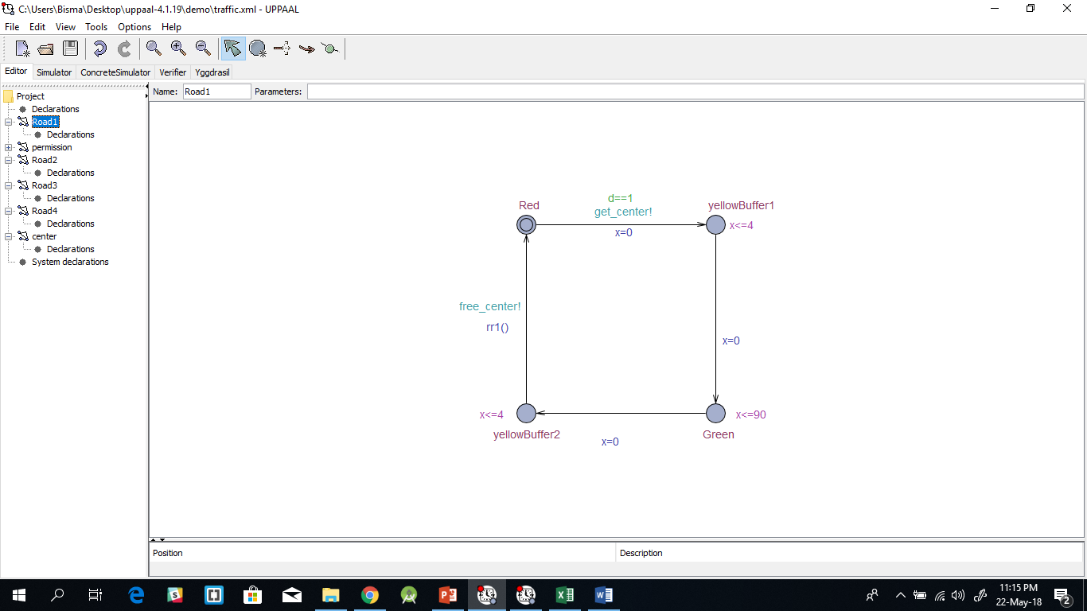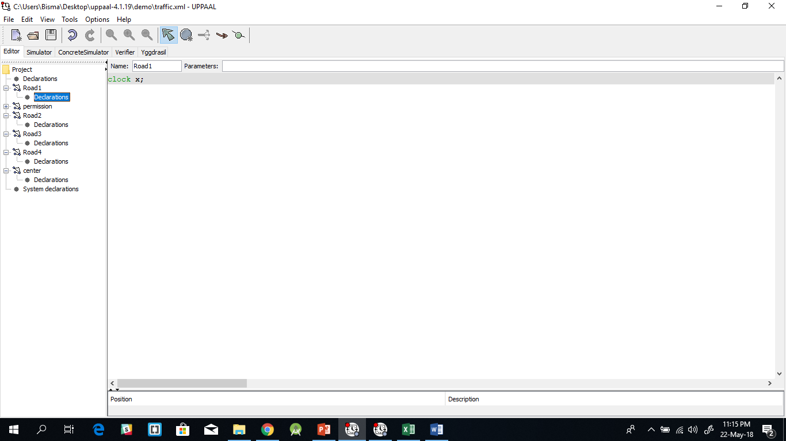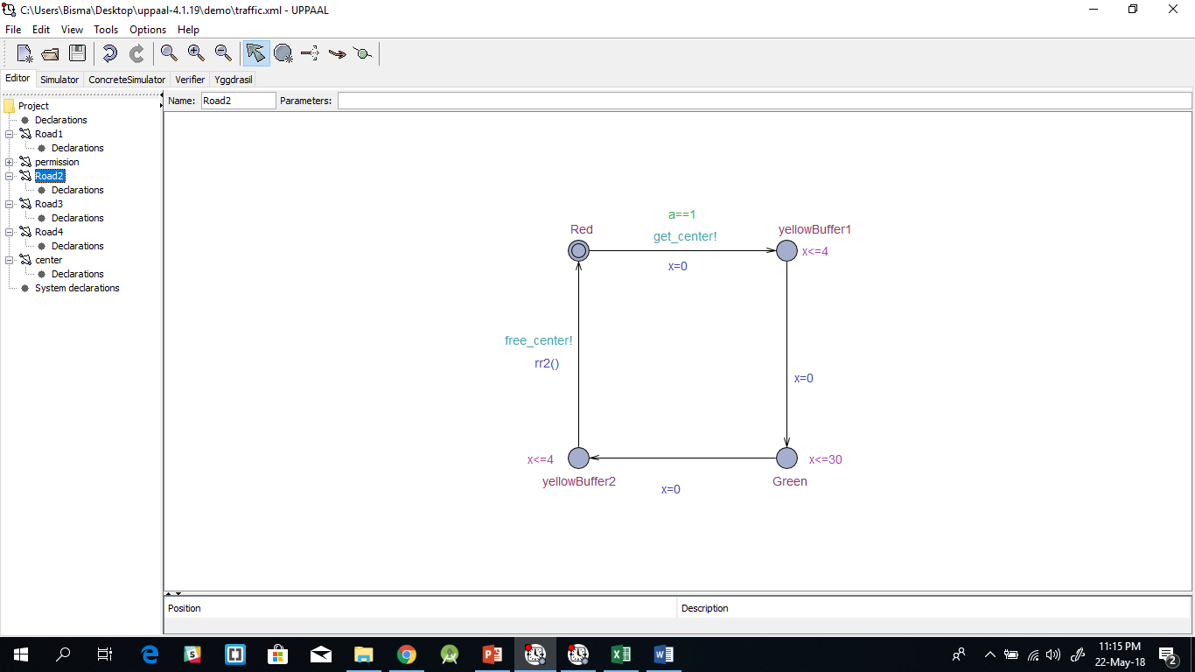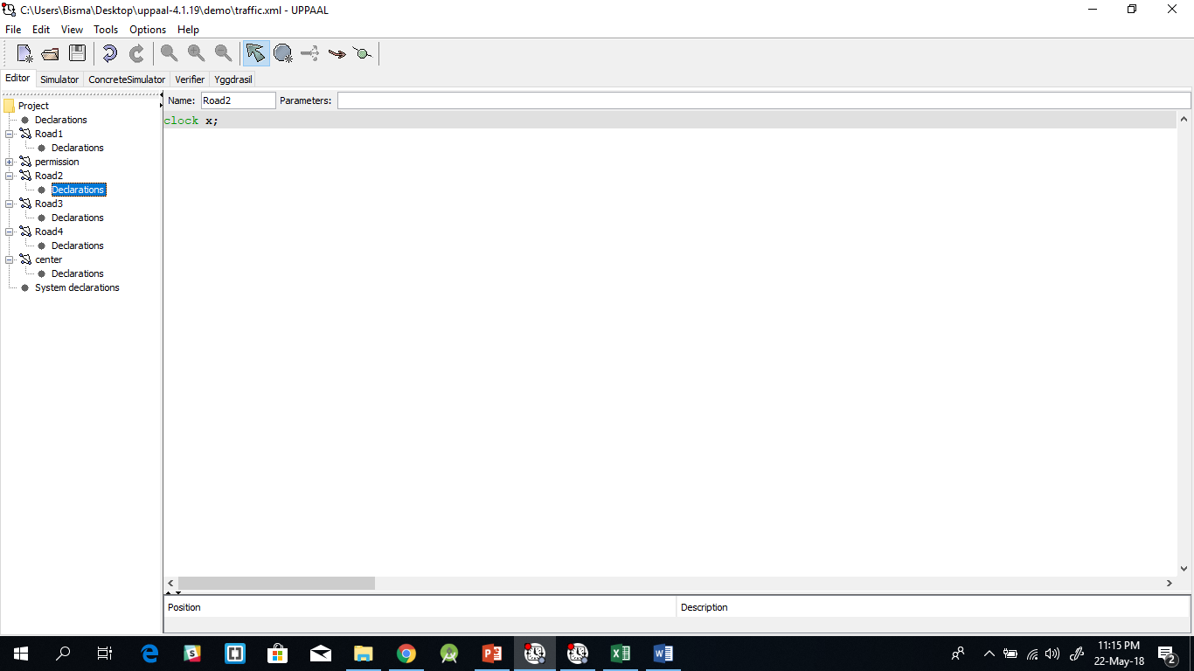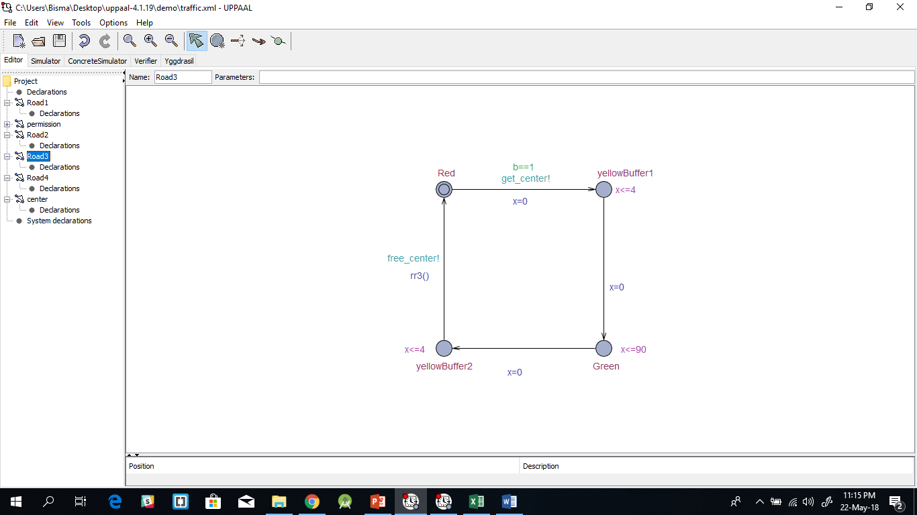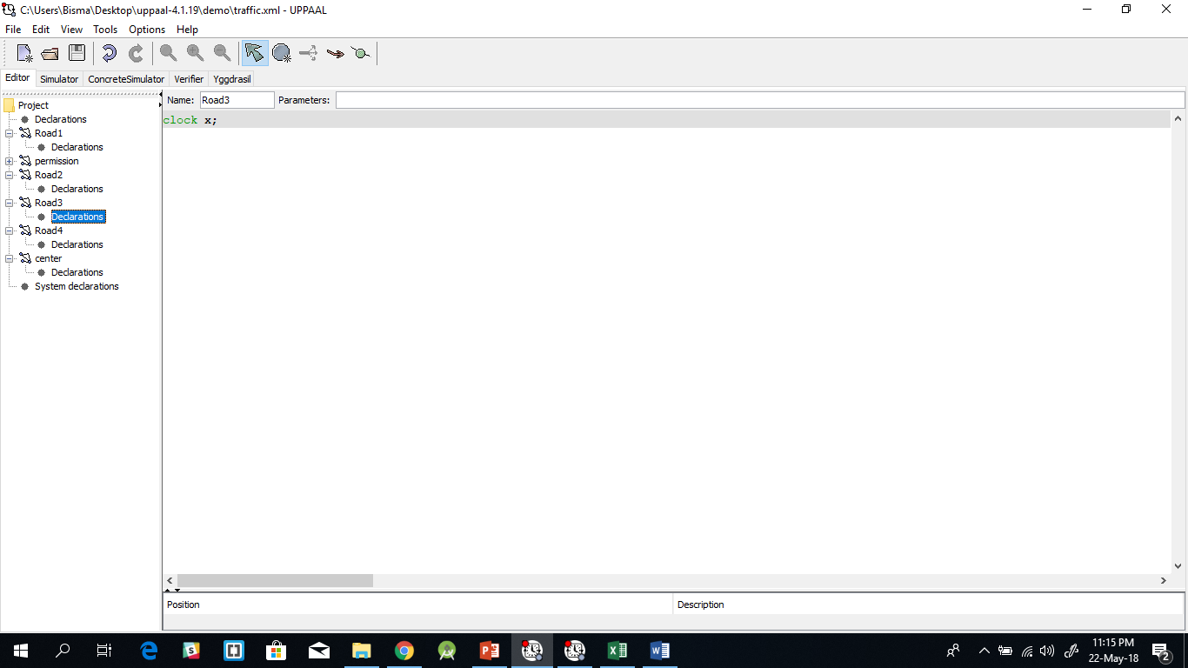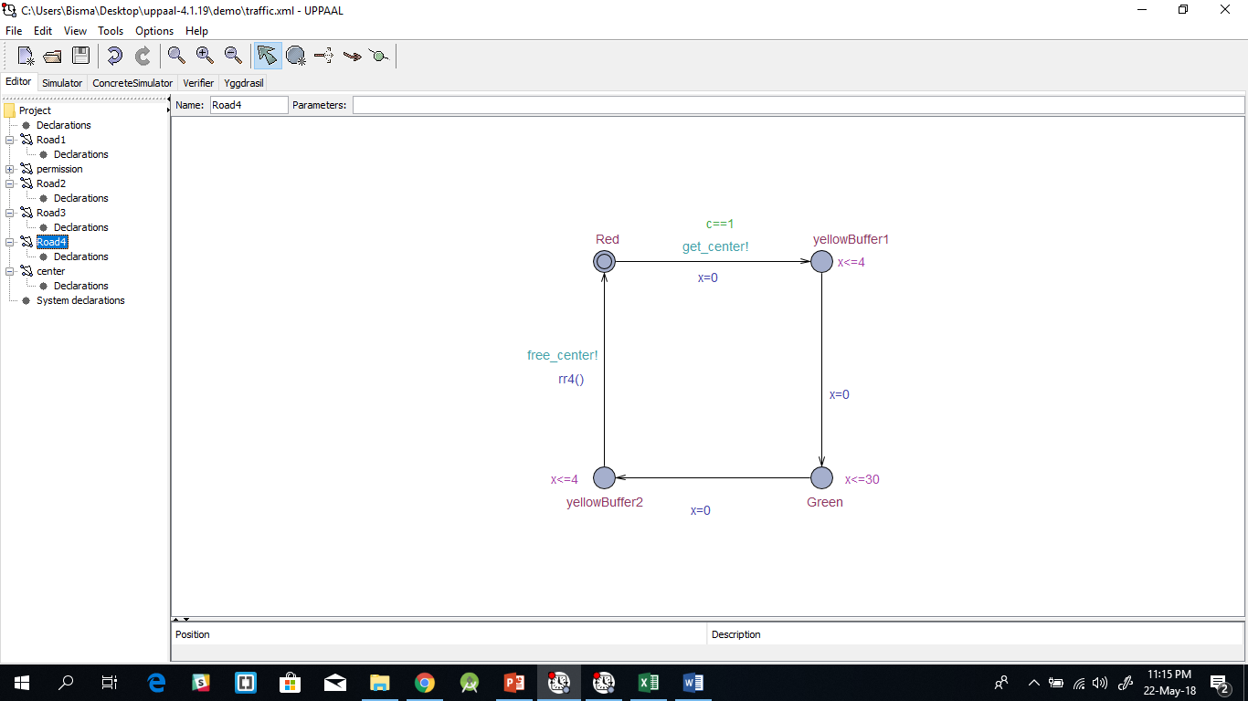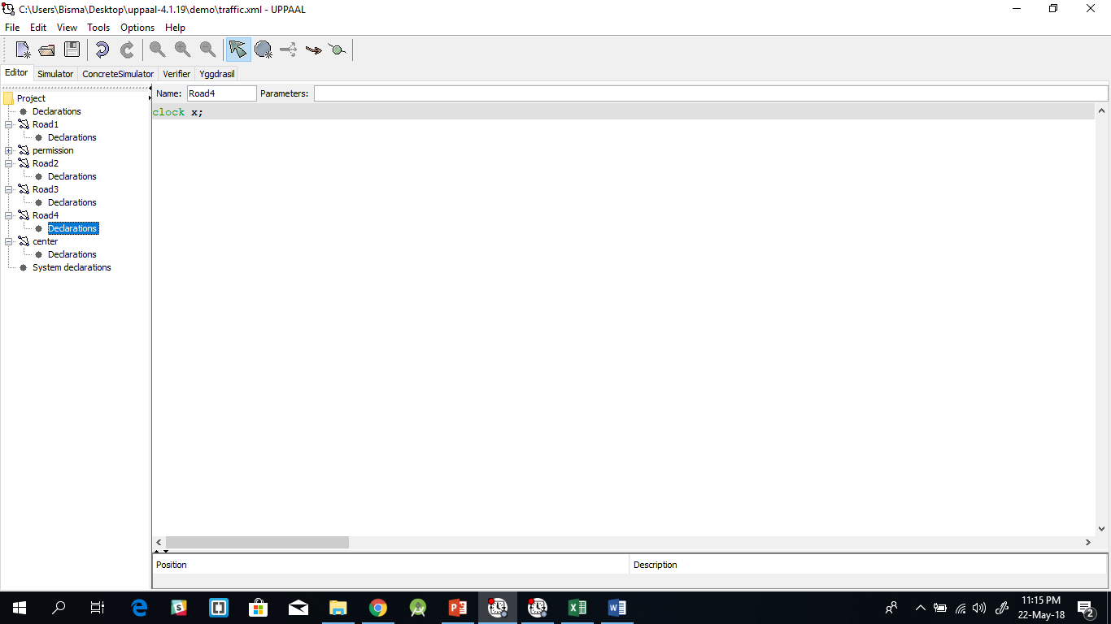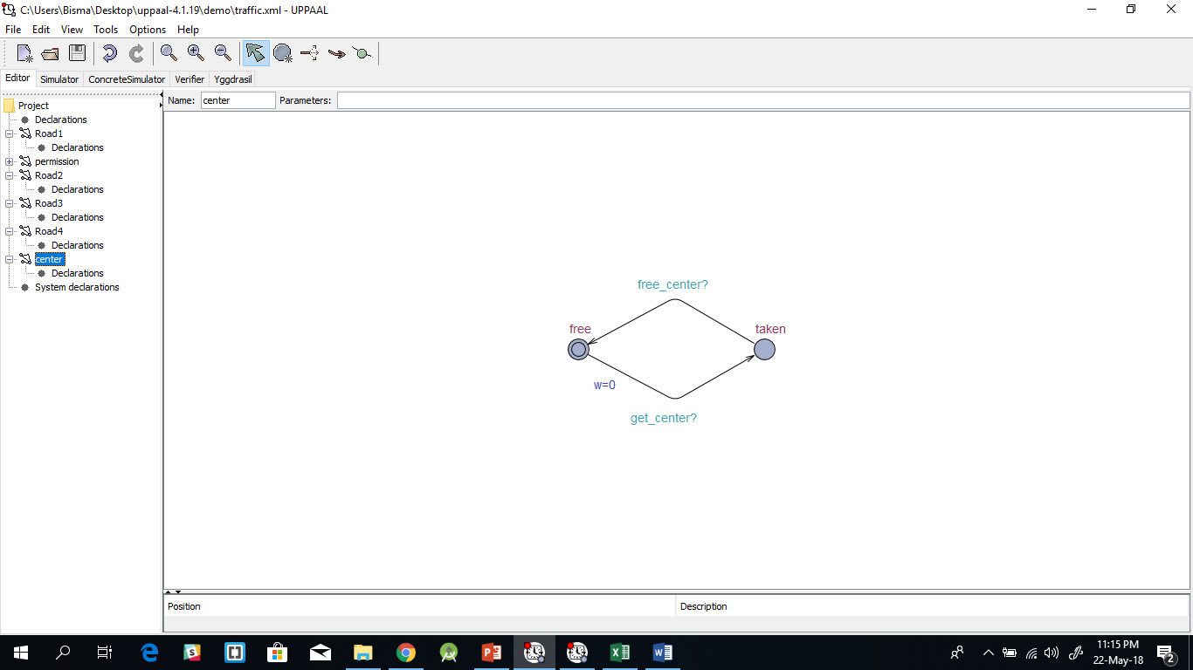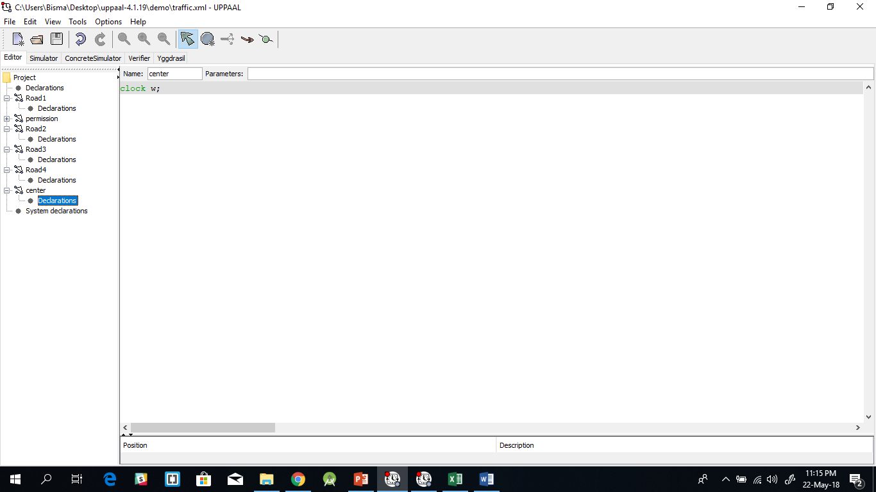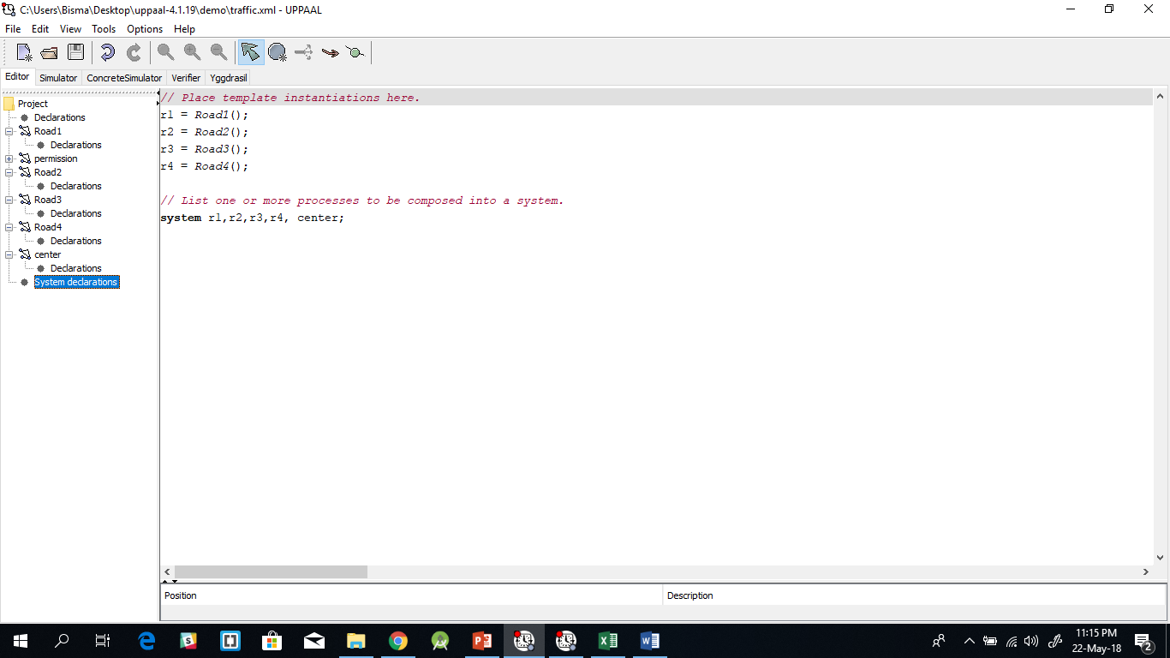

**Properties:**

1. **Mutex Property**: A[] not(r1.Green and r2.Green and r3.Green and r4.Green) this property states that all signals will not be green at the same time. For all future states not all roads will have signal green.
2. **Bounded liveness**: E<> r1.Green, E<> r2.Green, E<> r3.Green, E<> r4.Green. this property states that every road will have its signal green sometime in future.
3. **Deadlock avoidance**: A[] r1.Red and r2.Red and r3.Red and r4.Red. this property states that for all future states all roads must not always be on red signal. This is not satisfied hence it implies that the deadlock is avoided.
4. **My posts with comments**

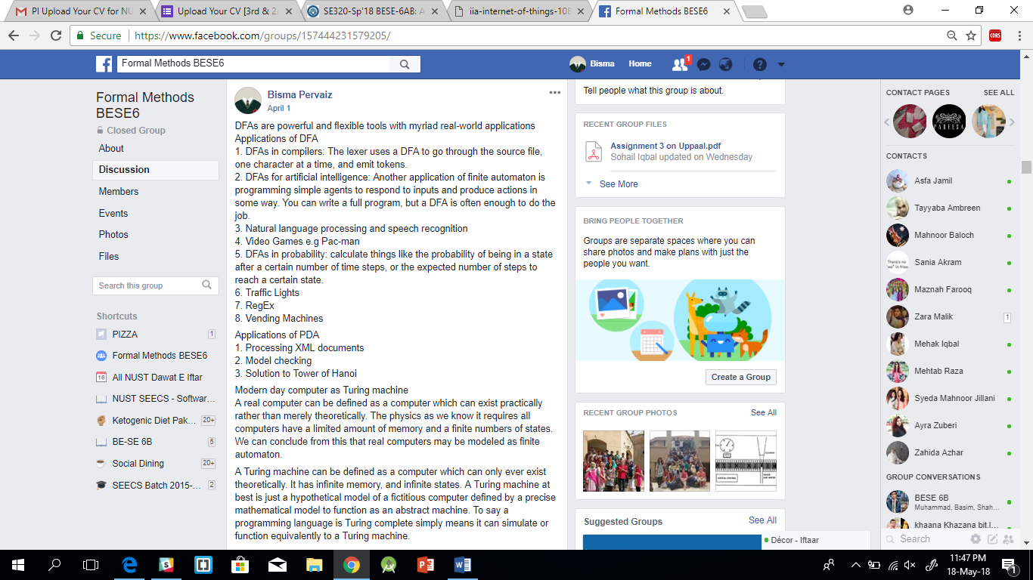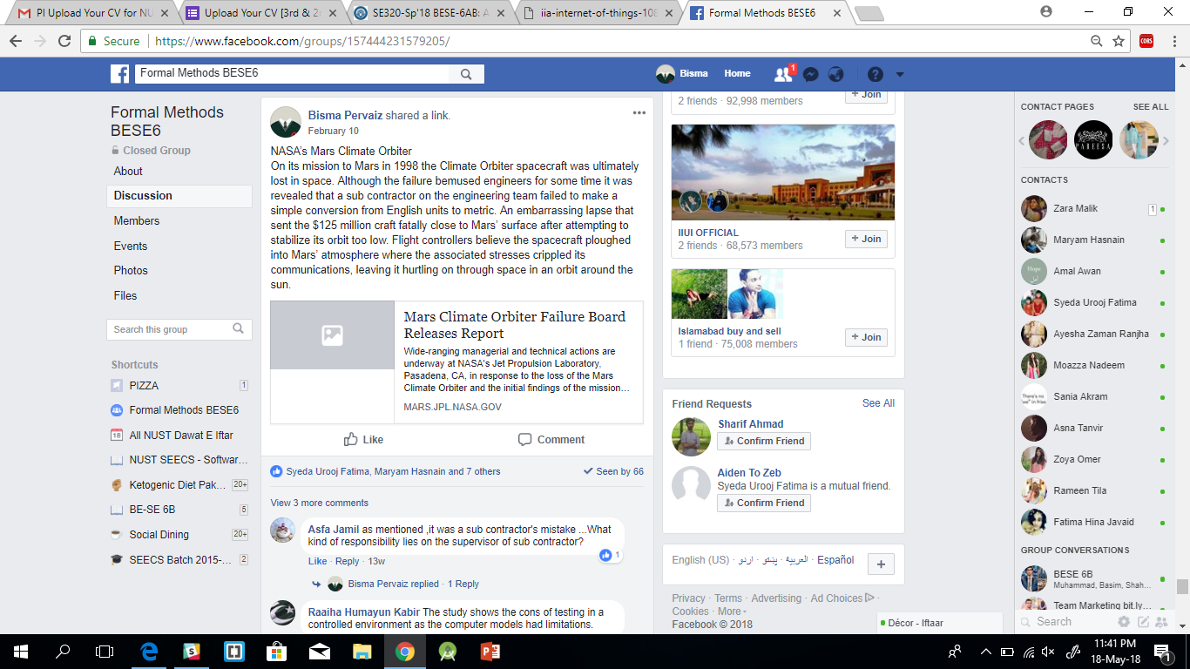

**My comments on other members post**

